When the patient logs in, they are directed to the Patient Dashboard, where they can view an overview of their current medications, upcoming reminders, and prescription renewals. The patient can also view recent prescriptions and download their information in PDF, Excel, or DOCX format.
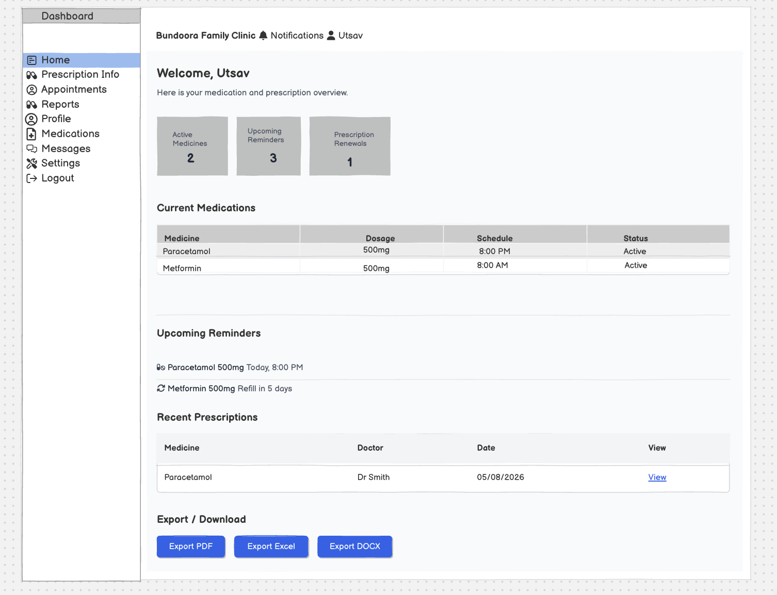

When the patient selects Prescription Info or clicks View on a prescription, they are directed to the Prescription Details page. Here, they can view the prescription ID, medicine, dosage, frequency, prescribing doctor, issue date, refill due date, medication instructions, and prescription history. If the prescription requires renewal, the patient can select Request Renewal to submit a renewal request.
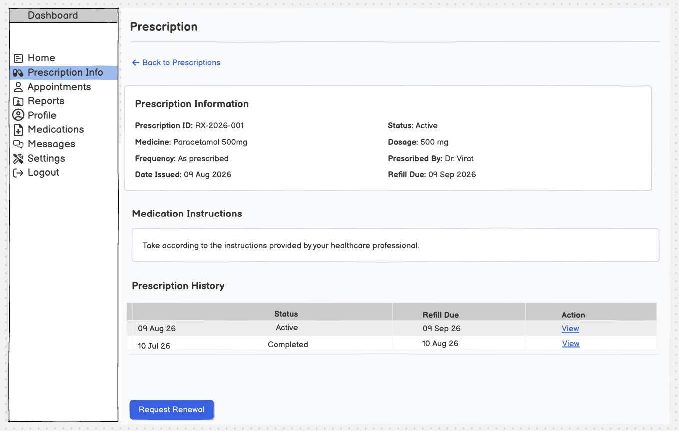

When the patient selects Profile, they are directed to the My Profile page, where they can view their personal and account information, including their Patient ID, date of birth, phone number, and email address. The patient can select Edit Profile to update their details and can also view an overview of their current medications, upcoming reminders, prescription renewals, and next refill.
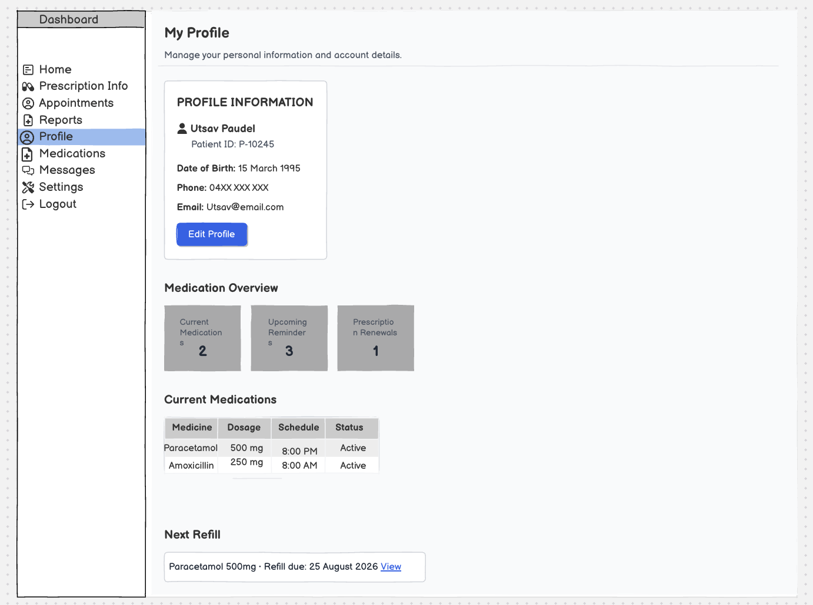

When the user selects Medications, they are directed to the Medication Management page, where they can monitor active medications, refill dates, and prescription renewals. The page also displays medication details, medication alerts, duplicate-prescription warnings, upcoming refill information, and recent prescription activity for review.
